Update: Part2 Report

Member: Xince Shi (xshi16@ucsc.edu)

I want to make a game about maze escape in a 3D cartoony world.

The sample picture that I found online:

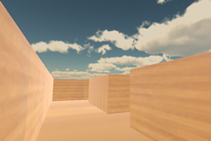

Fixed the map.

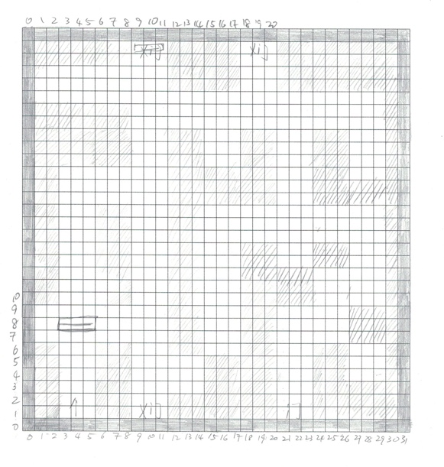

This is the map design by hand drawing

Reset the rules.

There are some doors, player will try to find the right door to win.

When player gets the front of the right door, player will see the check mark.

Add:

light in the game world

some doors

the check mark at the right door

Problems fixed:

To find the current position and check if in the right door area.

Set light with texCoord

Use keyboard to control the view to turn right or left

Problems not fixed:

player can move through the wall

Final Project

Member: Xince Shi (xshi16@ucsc.edu)

I want to make a game about maze escape in a 3D cartoony world.

The sample picture that I found online:



Goal：

It will have the walls, ground and sky with light and shadows. Player can use keyboard and mouse to control vision. And player can not move through the wall.

Part1:

It has the walls, ground and sky. . Player can use keyboard and mouse to control vision.

Player must click start button to start the game.

Part2:

The world has light and shadows. The player can not move through the wall. Fix the map to become better.